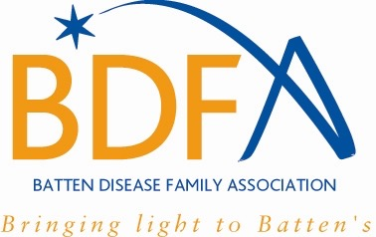

BDFA FAMILY NETWORKING WEEKEND: 8 – 9 NOVEMBER 2014
FEEDBACK FORM

We really enjoyed our 2014 Family Networking Weekend and hope you did too. It is your conference and in order to make it even better next year, we would value your feedback on any aspect of it, either positive or negative. Please can you therefore answer the following questions:

- What were your main reasons for attending this event?

- Which parts worked best for you?

- Which parts were of least interest to you?

- Do you have any comments on the presentations?

- Please give details of anything else you would like to see included in future family networking weekends.

- Please let us know any other comments you may have about the weekend.

- If you wish to comment on any other aspects of the BDFA, please complete our survey on the BDFA and its services at https://www.monkeysurvey.com/s/HLTXPFX

